1. **Total Loan Applications: -**

Select count(id) as Total_Loan_Applications from bank_loan_data



1. **Month to Date total loan applications: -**

Select count(id) as MTD_Total_Loan_Applications from bank_loan_data

WHERE YEAR(issue_date) = (SELECT MAX(YEAR(issue_date)) FROM bank_loan_data)

AND MONTH(issue_date) = (SELECT MAX(MONTH(issue_date)) FROM bank_loan_data)

1. **Previous Month total loan applications: -**

Select count(id) as Prev_MTD_Total_Loan_Applications from bank_loan_data

WHERE YEAR(issue_date) = (SELECT MAX(YEAR(issue_date)) FROM bank_loan_data)

AND MONTH(issue_date) = (SELECT (MAX(MONTH(issue_date))-1) FROM bank_loan_data)

1. **Total funded Amount**   
   Select SUM(loan_amount) as Total_funded_amt from bank_loan_data

1. **Month To date Total funded Amount**

Select SUM(loan_amount) as MTD_Total_funded_amt from bank_loan_data

WHERE YEAR(issue_date) = (SELECT MAX(YEAR(issue_date)) FROM bank_loan_data)

AND MONTH(issue_date) = (SELECT MAX(MONTH(issue_date)) FROM bank_loan_data)

1. **Previous Month To date Total funded Amount**

Select SUM(loan_amount) as Prev_MTD_Total_funded_amt from bank_loan_data

WHERE YEAR(issue_date) = (SELECT MAX(YEAR(issue_date)) FROM bank_loan_data)

AND MONTH(issue_date) = (SELECT MAX(MONTH(issue_date)-1) FROM bank_loan_data)

1. **Total Payment received by bank**

select sum(total_payment) as Total_Amount_Received from bank_loan_data

1. **Month to date Total Payment received by bank**

select sum(total_payment) as MTD_Total_Amount_Received from bank_loan_data

WHERE YEAR(issue_date) = (SELECT MAX(YEAR(issue_date)) FROM bank_loan_data)

AND MONTH(issue_date) = (SELECT MAX(MONTH(issue_date)) FROM bank_loan_data)

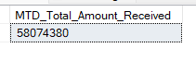

1. **Previous Month Total Payment received by bank**

select sum(total_payment) as Prev_Total_Amount_Received from bank_loan_data

WHERE YEAR(issue_date) = (SELECT MAX(YEAR(issue_date)) FROM bank_loan_data)

AND MONTH(issue_date) = (SELECT MAX(MONTH(issue_date)-1) FROM bank_loan_data)

1. **Average Interest Rates**

Select ROUND(AVG(int_rate),4)*100 as Average_Int_Rate from bank_loan_data

1. **Month to date Average Interest Rates: -**

Select ROUND(AVG(int_rate),4)*100 as MTD_Average_Int_Rate from bank_loan_data

WHERE YEAR(issue_date) = (SELECT MAX(YEAR(issue_date)) FROM bank_loan_data)

AND MONTH(issue_date) = (SELECT MAX(MONTH(issue_date)) FROM bank_loan_data)



1. **Previous Month Average Interest Rates: -**

Select ROUND(AVG(int_rate),4)*100 as Prev_Month_Average_Int_Rate from bank_loan_data

WHERE YEAR(issue_date) = (SELECT MAX(YEAR(issue_date)) FROM bank_loan_data)

AND MONTH(issue_date) = (SELECT MAX(MONTH(issue_date)-1) FROM bank_loan_data)

1. **Average Debt to Income Ratio: -**

Select ROUND(AVG(dti),4)*100 as Avg_DTI from bank_loan_data

1. **Month to date Average Debt to Income Ratio: -**

SELECT ROUND(AVG(dti),4)*100 as MTD_Avg_DTI FROM bank_loan_data

WHERE YEAR(issue_date) = (SELECT MAX(YEAR(issue_date)) FROM bank_loan_data)

AND MONTH(issue_date) = (SELECT MAX(MONTH(issue_date)) FROM bank_loan_data)

1. **Previous Month Average Debt to Income Ratio: -**

SELECT ROUND(AVG(dti),4)*100 as Prev_Month_Avg_dti from bank_loan_data

WHERE YEAR(issue_date) = (SELECT MAX(YEAR(issue_date)) from bank_loan_data)

AND MONTH(issue_date) = (SELECT MAX(MONTH(issue_date)-1) from bank_loan_data)

1. **Total Good Loan Applications: -**

Select count(id) as Total_Good_appl from bank_loan_data

WHERE loan_status='Fully Paid' OR loan_status = 'Current'



1. **Good Loan Applications Percentage: -**

SELECT

((SELECT COUNT(id) FROM bank_loan_data WHERE loan_status = 'Fully Paid' OR loan_status = 'Current') * 100) /

(SELECT COUNT(id) FROM bank_loan_data) AS good_loan_percentage;

1. **Good Loan Amount Disbursed: -**

Select SUM(loan_amount) as Total_Goodloan_amt from bank_loan_data

WHERE loan_status='Fully Paid' OR loan_status = 'Current'



1. **Total Payment in Good Loan: -**

Select SUM(total_payment) as Total_goodloan_pay from bank_loan_data

WHERE loan_status in ('Fully Paid','Current')



1. **Total Good Loan Applications: -**

Select count(id) as Total_bad_loan_applications from bank_loan_data

WHERE loan_status='Charged Off'

1. **Bad Loan Applications Percentage: -**

Select

(COUNT(CASE WHEN loan_status='Charged Off' THEN id END)*100)/

COUNT(id) as bad_loan_percentage from bank_loan_data

(SELECT COUNT(id) FROM bank_loan_data) AS Bad_loan_percentage;

1. **Bad Loan Amount Disbursed: -**

Select Sum(loan_amount) as total_bad_loan_funded_amt from bank_loan_data

WHERE loan_status='Charged Off'

1. **Total Payment in Bad Loan: -**

Select Sum(total_payment) as Total_bad_loan_pay from bank_loan_data

WHERE loan_status ='Charged Off'

1. **Total Summary: -**

select

loan_status,

COUNT(id) AS Total_Loan_Applications,

SUM(total_payment) as Total_amt_received,

SUM(loan_amount) as Total_funded_amt,

AVG(int_rate * 100) as Interest_rate,

AVG(dti * 100) as Debt_to_Income

From bank_loan_data GROUP BY loan_status

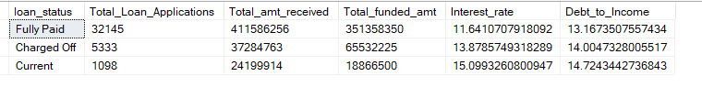

1. **Month to Date Total Summary: -**

select

loan_status,

COUNT(id) AS Total_Loan_Applications,

SUM(total_payment) as Total_amt_received,

SUM(loan_amount) as Total_funded_amt,

AVG(int_rate * 100) as Interest_rate,

AVG(dti * 100) as Debt_to_Income

From

bank_loan_data

WHERE

YEAR(issue_date) = (Select MAX(YEAR(issue_date)) from bank_loan_data) AND

MONTH(issue_date)=(Select MAX(Month(issue_date)) from bank_loan_data)

GROUP BY

loan_status

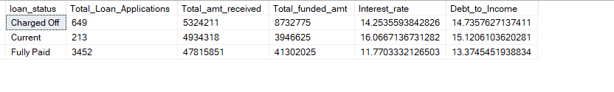

1. **Previous Month Total Summary: -**

select

loan_status,

COUNT(id) AS Total_Loan_Applications,

SUM(total_payment) as Total_amt_received,

SUM(loan_amount) as Total_funded_amt,

AVG(int_rate * 100) as Interest_rate,

AVG(dti * 100) as Debt_to_Income

From bank_loan_data WHERE YEAR(issue_date) = (Select MAX(YEAR(issue_date)) from bank_loan_data) and

MONTH(issue_date)=(Select MAX(Month(issue_date)-1) from bank_loan_data)

GROUP BY loan_status

# Overview

1. **Monthly Trends: -**

SELECT

MONTH(issue_date) as "Month_No.",

DATENAME(MONTH, issue_date) AS Month_name,

COUNT(id) AS Total_loan_applications,

SUM(loan_amount) as Total_funded_amt,

SUM(total_payment) as Total_received_amt

FROM

bank_loan_data

GROUP BY

DATENAME(MONTH, issue_date),MONTH(issue_date)

ORDER BY

MONTH(issue_date)

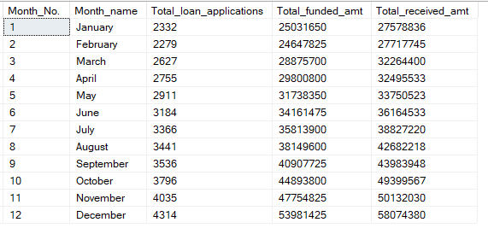

1. **Trend BY Region: -**

SELECT

address_state,

COUNT(id) AS Total_loan_applications,

SUM(loan_amount) as Total_funded_amt,

SUM(total_payment) as Total_received_amt

FROM

bank_loan_data

GROUP BY

address_state

ORDER BY

SUM(loan_amount) DESC

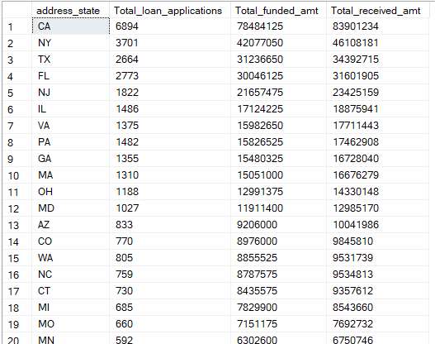

1. **Loan term**

SELECT

term,

COUNT(id) AS Total_loan_applications,

SUM(loan_amount) as Total_funded_amt,

SUM(total_payment) as Total_received_amt

FROM

bank_loan_data

GROUP BY

term

ORDER BY

Term

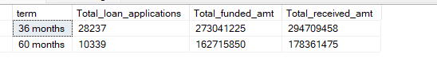

1. **BY Employee Length**

SELECT

emp_length,

COUNT(id) AS Total_loan_applications,

SUM(loan_amount) as Total_funded_amt,

SUM(total_payment) as Total_received_amt

FROM

bank_loan_data

GROUP BY

emp_length

ORDER BY

Count(id) DESC

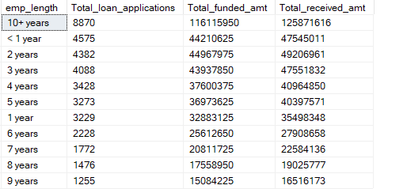

1. **Purpose of taking loan:-**

SELECT

purpose,

COUNT(id) AS Total_loan_applications,

SUM(loan_amount) as Total_funded_amt,

SUM(total_payment) as Total_received_amt

FROM

bank_loan_data

GROUP BY

purpose

ORDER BY

Count(id) DESC

1. **By Home ownership**

SELECT

home_ownership,

COUNT(id) AS Total_loan_applications,

SUM(loan_amount) as Total_funded_amt,

SUM(total_payment) as Total_received_amt

FROM

bank_loan_data

GROUP BY

home_ownership

ORDER BY

Count(id) DESC

